DSC 640

Week 11 and 12

Amy Nestingen

11/8/2020

Histograms, Box Plots, and Bullet Charts

# R

Histogram

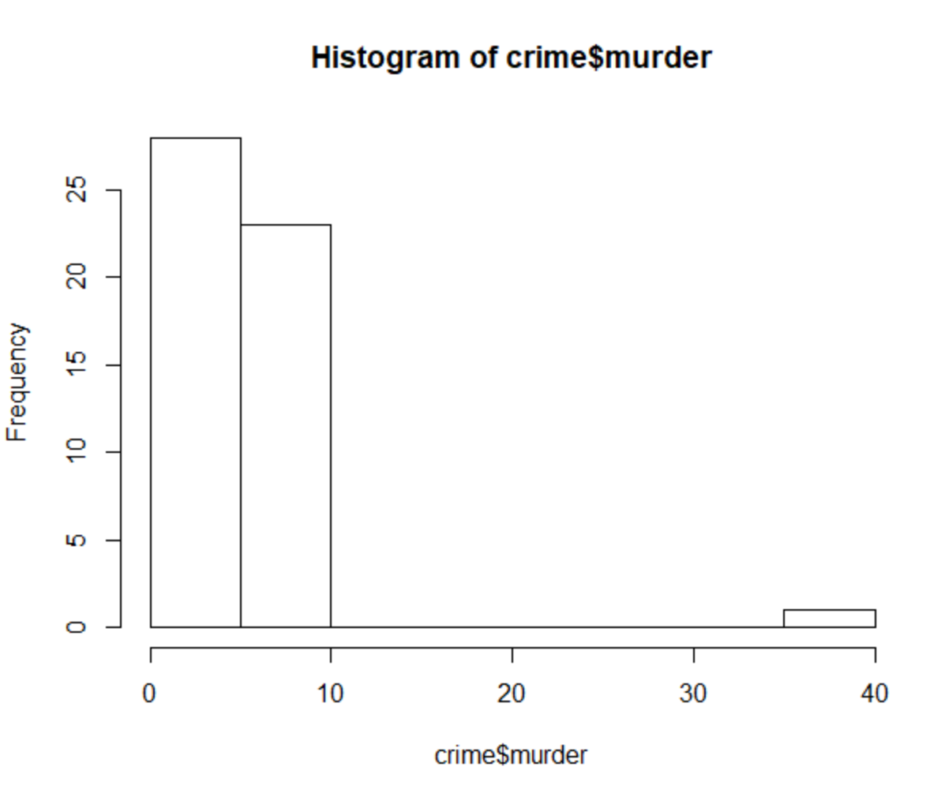

Box Plots

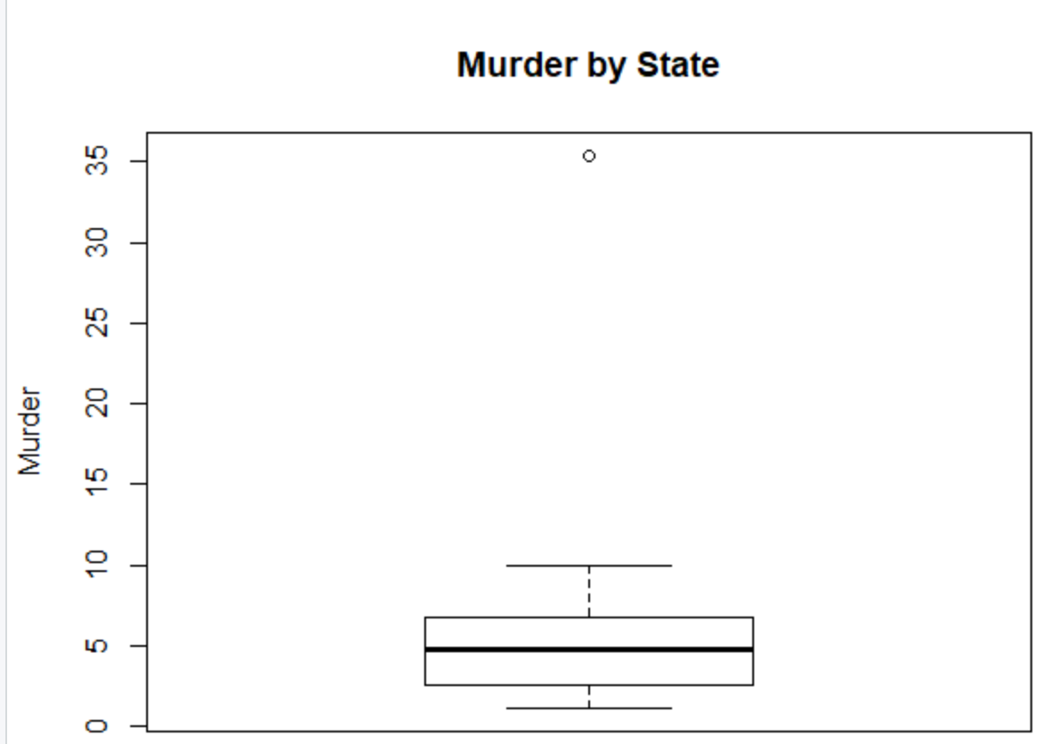

Bullet Charts

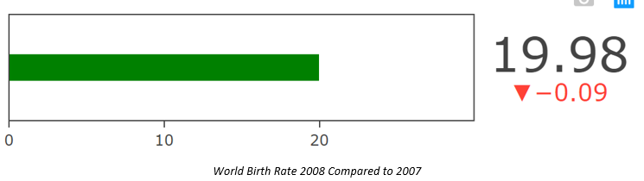

# Python

Histogram

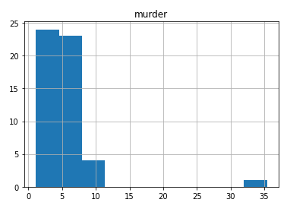

Box Plots

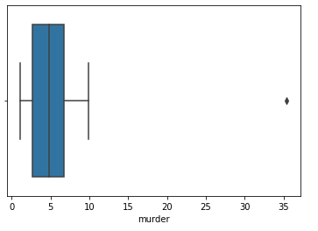

Bullet Charts

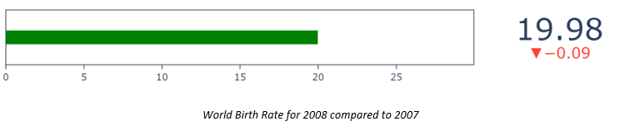

# PowerBI

Histogram

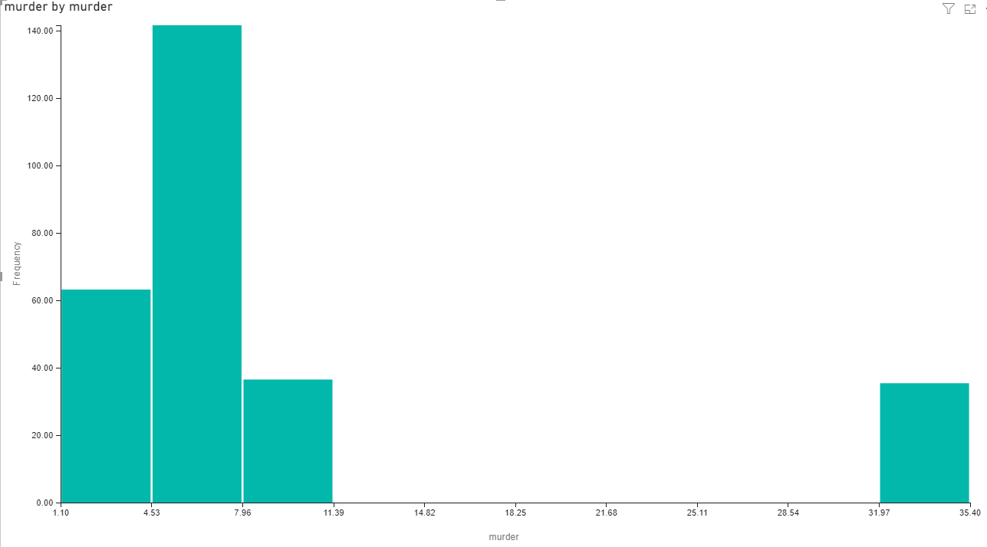

Box Plots

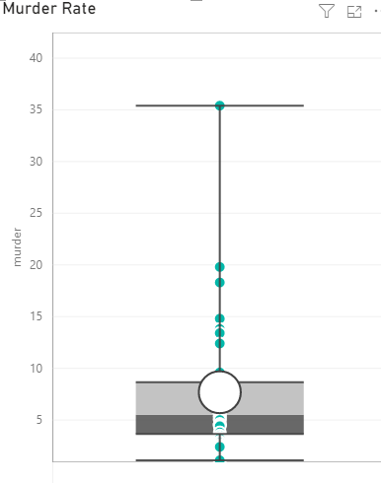

Bullet Charts

